Yunus Can Dumlupınar

218CS2109

***HCI HW5***

In this project I aim to represent a vehicle insurance company policy. In this policy there is various vehicle marks and 2 options for age of vehicles. At the start of the program user will face with a java frame. In this frame there is a combo box which allows user to select mark of his/her car(s). After the combo box user must select one of the age option for the corresponding vehicle. There are two radio button which allows user to gives input of the age of vehicle. After that user should use one of the 4 buttons. The buttons are “Calculate”, “Next”, “Show Current Bill” and “Exit”. User will finish his job then use will “Exit” button to terminate the system. User can make insurance for multiple vehicles. Before the billing he/she also can see his payment. He/she can also see all vehicles that he/she had made insurance before terminate the program.

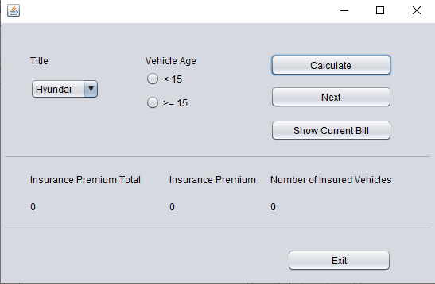

There are 9 tittles supported for making insurance in the company. The tittles are Hyundai, BMW, Mercedes, Toyota, Renault, Ferrari, Ford, Opel and Skoda. These titles can be selected from the Combo box named “Tittle”.

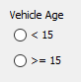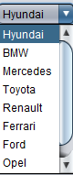

At the right side of the combo box there is 2 radio buttons. Only one can be selected. İf you did not check any one of these you program going to warn you. It going to say “No age attribute has been chosen. Please choose an age attribute to continue.” İf you select both radio buttons at the same time program will warn you again. This time it going to say you “You can not choose both of the options at once. Please select only one age attribute to continue.”

At the right of side of the radio buttons there are three buttons. Named as “Calculate”, “Next”, and “Show Current Bill”. User will use the Calculate button to see how much price is the corresponding car insurance costs. When the calculate button is activated, insurance premium value is going to change as cost of the price. User will use this button until he finishes his job.

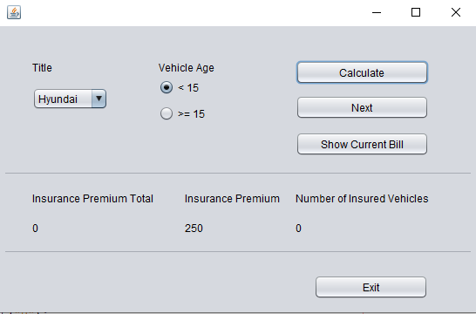

After the calculate button user going to use “Next” button. When the next button is activated insurance premium value will reset to “0” but it’s previous value will be added into Insurance Premium Total value. For example Insurance Premium Value Total =100 and Insurance Premium =500. After using the “Next” button the values going to change like this : Insurance Premium Total =600 and Insurance Premium =0. Insurance Premium Total shows us the total price of all insurances(multi-vehicles etc.). There is also a counter which counts number of vehicles has been insured. Every time “Next” button triggered, counter will be increase by 1. Don’t forget, if you haven’t use calculate button , but you triggered next, program will warn you and going to say “You must calculate first!”.

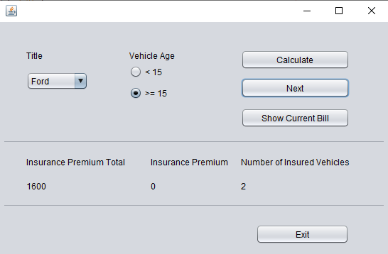

Below the “Next” button there is “Show Current Bill” button. When user clicks the button the Title of the vehicle, insurance price of the corresponding vehicle and Insurance Premium Total will shown at the output. İf any vehicles has been insured then the program will warn the and says “You haven't add any vehicle yet!”. See the example;

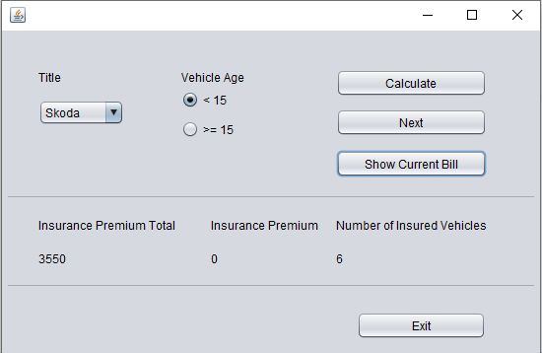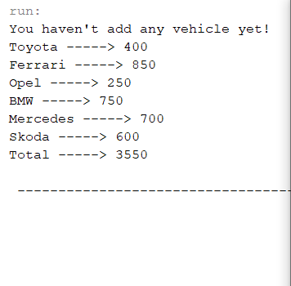

At the bottom there is exit button. Exit button will shown the total summary of the all processes that user made. It says “GoodBye!” to user then terminate the program.

